**Wine “mini” Ferment Monitoring Solution**

Problem: traditional ferment monitoring using laboratory testing is labour intensive with expensive ongoing costs.

Problem: whilst technology is available to automate ferment monitoring it can be difficult to implement, particularly when integration to the existing control system is required.

Solution: ifm efector mini ferment monitoring solution

The ifm mini ferment monitoring solution is a stand-alone system for real time measurement of Baume / Brix and density on a single fermenter. Whilst the system is expandable, the solution is ideal as a simple “proof of concept”.

Whilst differential pressure has long been available for density monitoring, the small pressure variations caused by density change during fermentation have meant traditional differential transmitters require ultra-thin metal diaphragms which are extremely fragile. Rupture of these metal diaphragms can release glycol or other fill materials and contaminate the wine.

The latest generation of ifm PI17xx pressure transmitters from ifm efector use robust ceramic diaphragms with no fill material that could contaminate the wine. They also utilize IO-Link technology to provide much higher resolution than available with traditional 4-20mA process signals, to accurately provide ferment measurements that reflect the values measured in the laboratory.

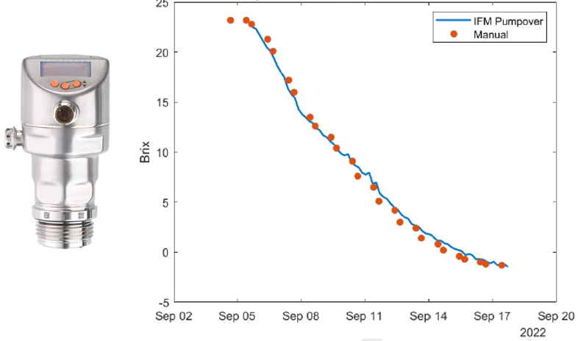

The ifm efector mini ferment monitoring system comprises the following components:

* CR1140 4.3” HMI / PLC with ferment monitoring program pre-loaded
* 4 port IO-Link master
* 2 x PI1707 1 Bar IO-Link pressure transmitters
* Temperature transmitter and cables to suit.

The 2 x PI1707 pressure transmitters are mounted a known distance apart. This value is generally 1-2 meters, with greater separation distance giving the better results. Mounting in pump over lines rather than directly in the tank wall is also possible to simplify the installation. The distance value is entered into the HMI using the operator interface to set the system up for operation. 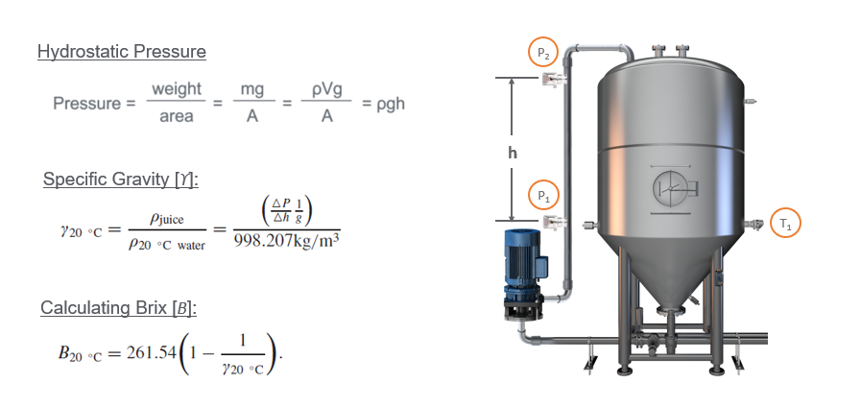

**System Layout**

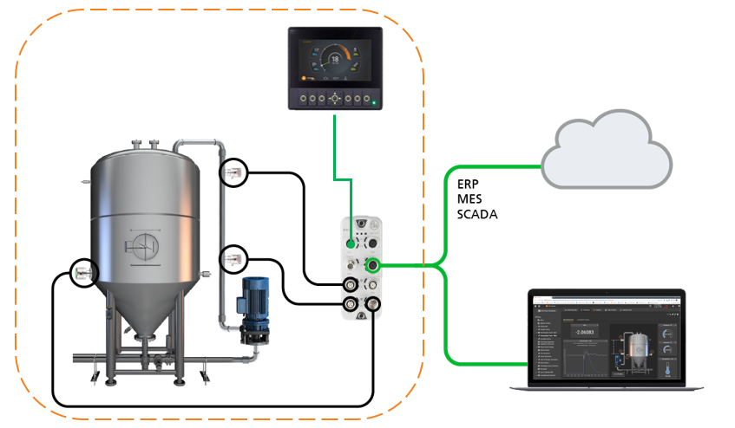 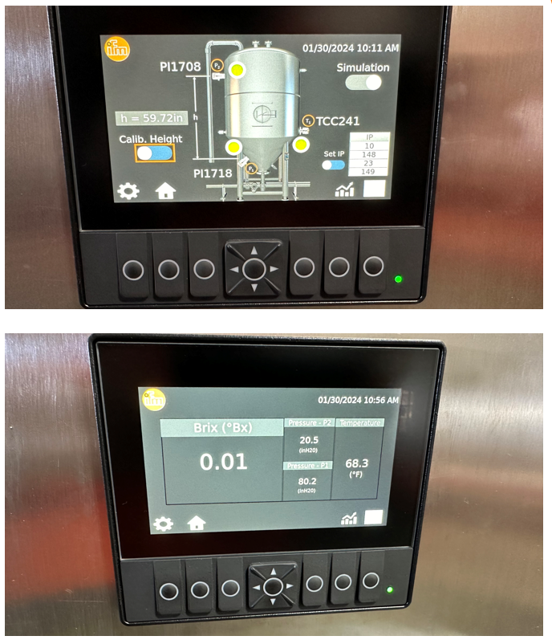

Whilst the system can operate stand-alone using the HMI display, information from the IO-Link master can be shared with higher level systems such as Ignition, SCADA, MES, ERP, etc.

Expansion of the system is possible by:

* adding additional “mini” ferment solutions with a CR1140 HMI controlling each fermenter, or
* substituting the CR1140 HMI with ifm AE3100 IIoT Controller with web visualisation, or
* substituting the CR1140 HMI with customers own PLC, or
* pushing data directly from the IO-Link master to ifm Moneo IIoT software, with Brix / Baume calculations performed within the software platform

**Moneo IIoT software**

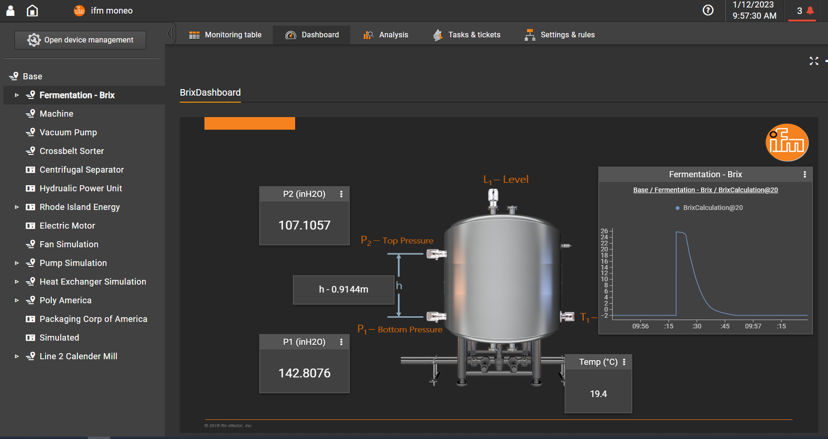

**Installation photos**

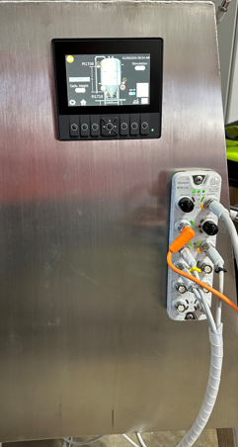 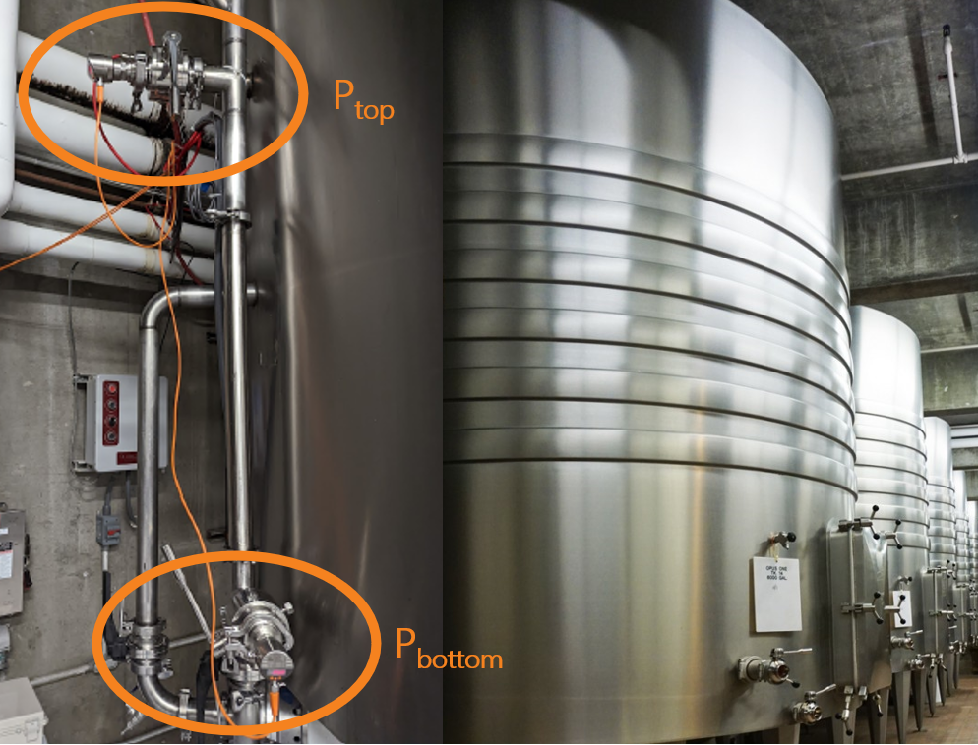

At present the mini ferment monitoring system has not been implemented in Australia, but ifm efector have extensive experience with wine ferment monitoring with major US wineries.

**Case study**

<https://www.ifm.com/us/en/shared/successstories/casestudies/automated-brix-calculation>

**Ifm ferment monitoring video**

<https://www.ifm.com/us/en/us/teaser-documents/industries/food/wine-brix-video>

**ifm Australia Wine Wise Solutions** <https://www.ifm.com/au/en/au/landingpages/wine/fermentation>